MEASURING THE PULSE OF PROSPERITY : AN INDEX OF ECONOMIC FREEDOM ANALYSIS

INTRODUCTION

Economic freedom is the fundamental right of every human to control his or her own labor and property. In an economically free society, individuals are free to work, produce, consume, and invest in any way they please. In economically free societies, governments allow labor, capital, and goods to move freely, and refrain from coercion or constraint of liberty beyond the extent necessary to protect and maintain liberty itself.

For much of human history, most individuals have lacked economic freedom and opportunity, condemning them to poverty and deprivation.

PURPOSE

Hundreds of studies in top-ranked academic journals show that economic freedom leads to positive outcomes for people, whether in **increased prosperity, reduced conflict, or stronger human rights.**

These indexes are motivated by the observation that economies that are more free-market based tend to experience greater levels of investment, more rapid growth, and higher average incomes.

ADVANTAGE

The most obvious benefit of economic freedom is that, as a system, it is the most conducive to widespread prosperity, that is, to high or rising income and consumption for the bulk of the population.

History strongly suggests that countries with more economic freedom grow faster—and those with less economic freedom sometimes don’t grow at all. The real GDP per capita of the United Kingdom, the spearhead of the Industrial Revolution, was multiplied by 16 in the three centuries since 1700, according to recent estimates from economic historians. Over the preceding 700 years, it had only doubled. Other Western countries, including Canada and the United States.

**DISADVANTAGE**

Increased efficiency, productivity, fair competition, and innovation are key advantages of a market economy. On the other hand, the disadvantages of a market economy are intense competition, poor working conditions, environmental degradation, and economic disparities.

**APPLICATION**

An index of economic freedom compares the jurisdiction against each other for various aspects, such as trade freedom, judicial effectiveness, and tax burden.

These factors may be weighed for their influence on economic freedom and collated into a single score for ranking.

**OUTPUT**

GDP PER CAPITA AND GDP GROWTH RATE:

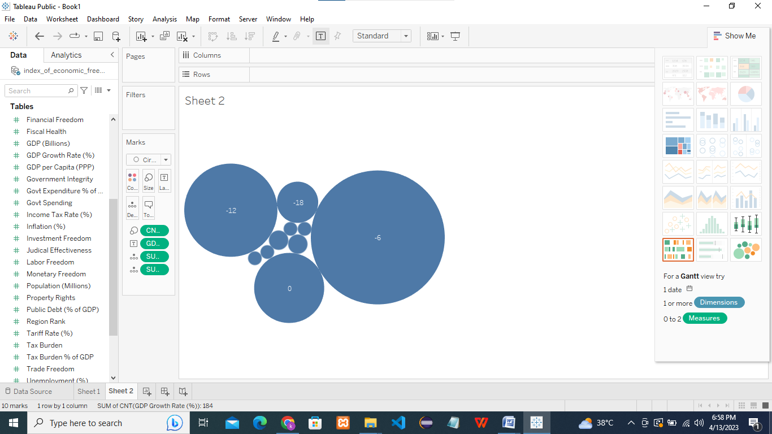

**Measures the change in the GDP of the country in comparison to an earlier period.**

UNEMPLOYMENT AND TRADE FREEDOM:

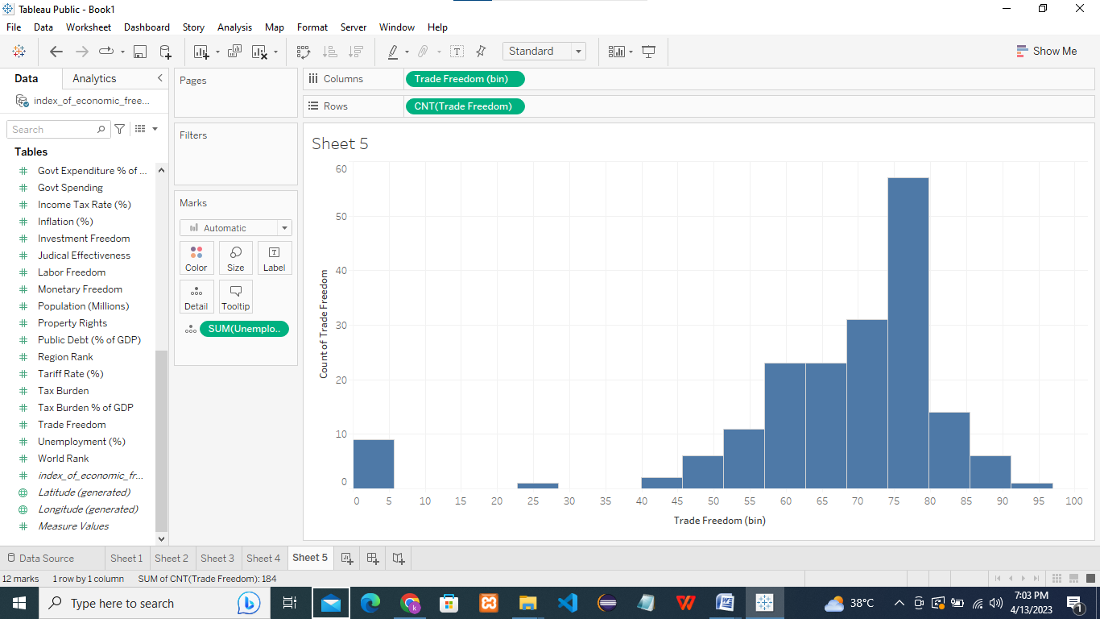

**A composite measure of the absence of tariff and non-tariff barriers that affect imports and exports of goods and services.**

**CONCLUSION:**

Tableau helps people and organizations be more data-driven

As the market-leading choice for modern business intelligence, our analytics platform makes it easier for people to explore and manage data, and faster to discover and share insights that can change businesses and the world.

It helps to calculate the growth of the country. So it can fulfill the needs of the country.

By using tableau we can easily analysis the datas.

It help us easy to find the up and downs of the country**.**